TASK 1:
#include <stdio.h>
int totalPower(int floors) {
if (floors <= 1) {
return 100;
}
int currentPower = 100;
for (int i = 1; i < floors; i++) {
currentPower = currentPower * 2;
}
return currentPower + totalPower(floors - 1);
}

int main() {
int floors;
int total;
printf("Enter the number of floors: ");
scanf("%d", &floors);

if (floors < 1) {
printf("Invalid input. Floors must be 1 or greater.\n");
return 0;
}
total = totalPower(floors);
printf("Total power consumed by %d floors is: %d kWh per day\n", floors, total);
return 0;
}
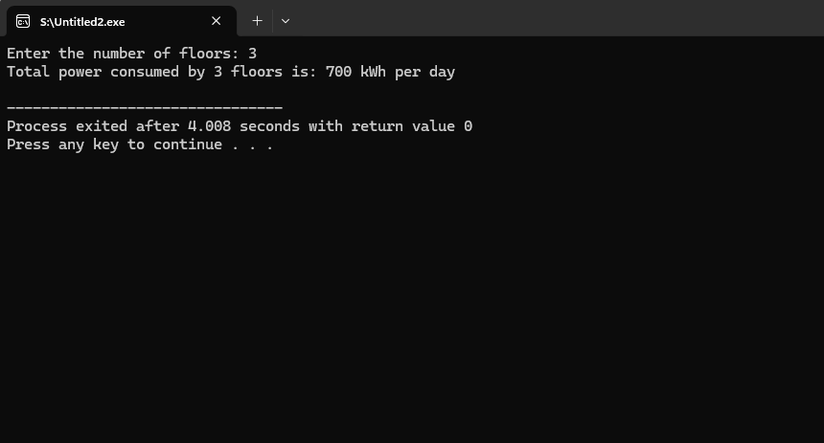
TASK 2:
#include <stdio.h>
int countUpper(char *str, int *digitCount) {
if (str[0] == '\0') {
return 0;
}

int isUpper = 0;
if (str[0] >= 'A' && str[0] <= 'Z') {
isUpper = 1;
}
if (str[0] >= '0' && str[0] <= '9') {
*digitCount = *digitCount + 1;
}
return isUpper + countUpper(str + 1, digitCount);
}
int main() {
char password[100];
int digits = 0;
int uppers;
printf("Enter a password to check: ");
scanf("%s", password);
uppers = countUpper(password, &digits);
printf("Uppercase letters found: %d\n", uppers);
printf("Digits found: %d\n", digits);
return 0;
}
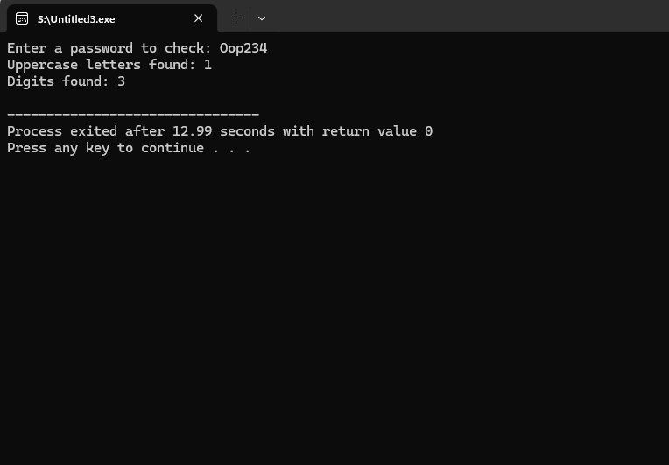
TASK 3:
#include <stdio.h>
int countWays(int n) {
if (n < 0) {
return 0;
}
if (n == 0 || n == 1) {
return 1;
}

return countWays(n - 1) + countWays(n - 2);
}

void printPaths(int n, int path[], int pathLen) {
if (n < 0) {
return;
}

if (n == 0) {
for (int i = 0; i < pathLen; i++) {
printf("%d", path[i]);
if (i < pathLen - 1) {
printf("+");
}
}
printf("\n");
return;
}

path[pathLen] = 1;
printPaths(n - 1, path, pathLen + 1);

path[pathLen] = 2;
printPaths(n - 2, path, pathLen + 1);
}

int main() {
int n;
int pathTracker[20];

printf("Enter destination N (1 to 15): ");
scanf("%d", &n);

if (n < 1 || n > 15) {
printf("Invalid input. Please enter between 1 and 15.\n");
return 0;
}

int total = countWays(n);
printf("Total distinct ways to reach step %d: %d\n\n", n, total);

printf("Unique paths to reach step %d:\n", n);
printPaths(n, pathTracker, 0);

return 0;
}
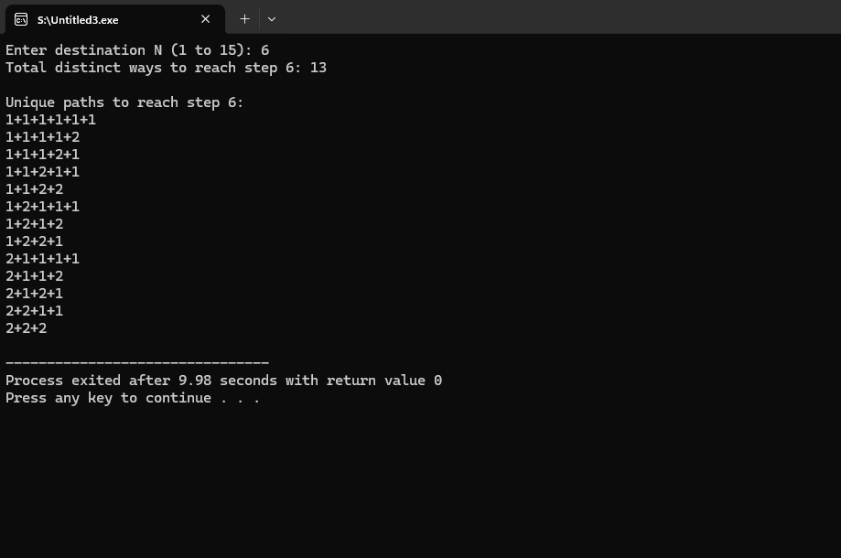
TASK 4:
#include <stdio.h>
#include <string.h>

struct Patient {
char name[50];
int age;
char bloodType[5];
int patientID;
char diagnosis[100];
};
void displayAll(struct Patient p[], int n) {
printf("\n--- Patient Records ---\n");
printf("%-10s | %-20s | %-5s | %-10s | %-30s\n", "ID", "Name", "Age", "Blood", "Diagnosis");
printf("--------------------------------------------------------------------------------------\n");
for (int i = 0; i < n; i++) {
printf("%-10d | %-20s | %-5d | %-10s | %-30s\n",
p[i].patientID, p[i].name, p[i].age, p[i].bloodType, p[i].diagnosis);
}
printf("\n");
}

void searchByID(struct Patient p[], int n, int id) {
for (int i = 0; i < n; i++) {
if (p[i].patientID == id) {
printf("\n--- Patient Found ---\n");
printf("ID: %d\n", p[i].patientID);
printf("Name: %s\n", p[i].name);
printf("Age: %d\n", p[i].age);
printf("Blood Type: %s\n", p[i].bloodType);
printf("Diagnosis: %s\n", p[i].diagnosis);
return;
}
}
printf("\nPatient not found.\n");
}

int main() {
struct Patient patients[5];
printf("Enter Hospital Patient Data \n");
for (int i = 0; i < 5; i++) {
printf("\nPatient %d:\n", i + 1);

printf("Name: ");
if (i == 0) {
gets(patients[i].name);
} else {
getchar();
gets(patients[i].name);
}
printf("Age: ");
scanf("%d", &patients[i].age);
printf("Blood Type: ");
scanf("%s", patients[i].bloodType);
printf("Patient ID: ");
scanf("%d", &patients[i].patientID);
printf("Diagnosis: ");
getchar();
gets(patients[i].diagnosis);
}

displayAll(patients, 5);
int searchId;
printf("Enter a Patient ID to search: ");
scanf("%d", &searchId);
searchByID(patients, 5, searchId);
return 0;
}
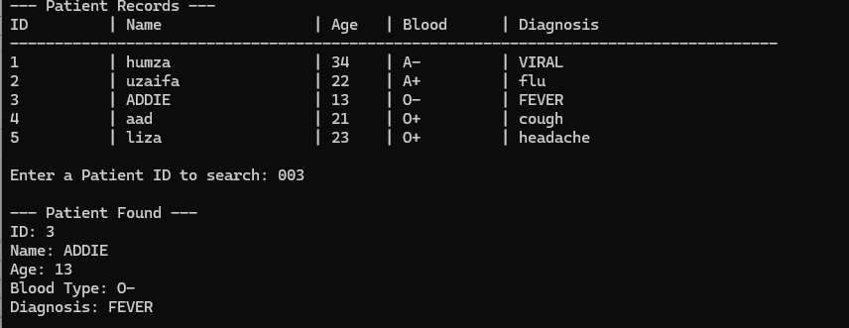
TASK 5:
#include <stdio.h>
#include <string.h>

struct Department {
char deptCode[10];
char deptName[50];
};
struct Course {
char courseCode[10];
char courseName[60];
int creditHours;
struct Department dept;
};
void searchByDepartment(struct Course catalog[], int size, char searchCode[]) {
int found = 0;
printf("\n--- Courses for Department: %s ---\n", searchCode);

for (int i = 0; i < size; i++) {
if (strcmp(catalog[i].dept.deptCode, searchCode) == 0) {
printf("Course: %s - %s\n", catalog[i].courseCode, catalog[i].courseName);
printf("Credits: %d\n", catalog[i].creditHours);
printf("Dept Name: %s\n\n", catalog[i].dept.deptName);
found = 1;
}
}
if (found == 0) {
printf("No courses found for this department code.\n");
}
}

int main() {
struct Course catalog[3];
printf("Enter Course Data \n");
for (int i = 0; i < 3; i++) {
printf("\nCourse %d:\n", i + 1);

printf("Course Code: ");
scanf("%s", catalog[i].courseCode);
getchar();
printf("Course Name: ");
gets(catalog[i].courseName);

printf("Credit Hours: ");
scanf("%d", &catalog[i].creditHours);

printf("Department Code: ");
scanf("%s", catalog[i].dept.deptCode);
getchar();
printf("Department Name: ");
gets(catalog[i].dept.deptName);
}

printf("\n Complete Course Catalog \n");
for (int i = 0; i < 3; i++) {
printf("Course: %s - %s (%d Credits)\n",
catalog[i].courseCode, catalog[i].courseName, catalog[i].creditHours);
printf("Department: %s (%s)\n\n",
catalog[i].dept.deptName, catalog[i].dept.deptCode);
}

char searchCode[10];
printf("Enter a Department Code to search: ");
scanf("%s", searchCode);
searchByDepartment(catalog, 3, searchCode);
return 0;
}
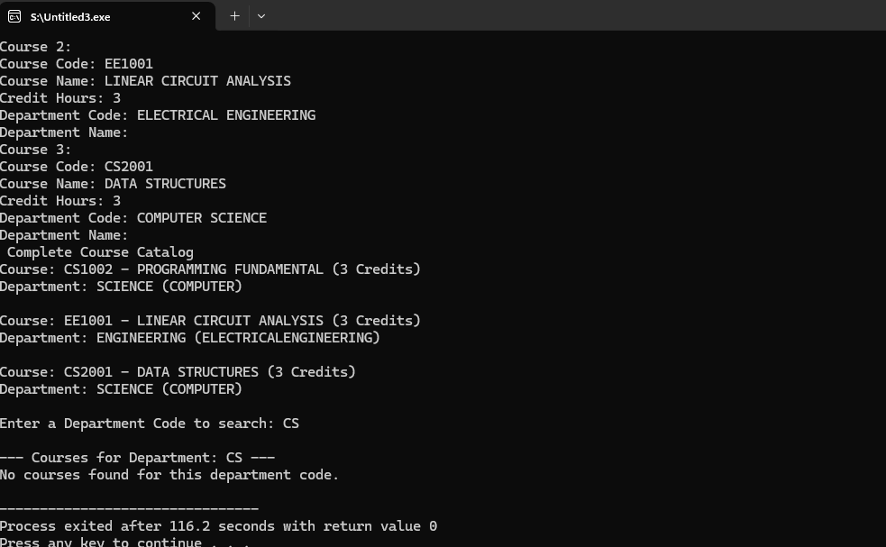
TASK 6:
#include <stdio.h>
#include <string.h>

struct Order {
int orderID;
char customerName[50];
char productName[50];
int quantity;
float unitPrice;
char status[20];
};

float computeTotal(struct Order o) {
return o.quantity * o.unitPrice;
}

void filterByStatus(struct Order orders[], int n, char *status) {
int found = 0;
printf("\n--- Orders with Status: %s ---\n", status);

for (int i = 0; i < n; i++) {
if (strcmp(orders[i].status, status) == 0) {
printf("Order ID: %d | Customer: %s | Product: %s\n",
orders[i].orderID, orders[i].customerName, orders[i].productName);
found = 1;
}
}

if (found == 0) {
printf("No orders found with that status.\n");
}
}

int main() {
struct Order orders[4];
printf("Enter E-Commerce Order Details \n");
for (int i = 0; i < 4; i++) {
printf("\nOrder %d:\n", i + 1);

printf("Order ID: ");
scanf("%d", &orders[i].orderID);
getchar();

printf("Customer Name: ");
gets(orders[i].customerName);

printf("Product Name: ");
gets(orders[i].productName);

printf("Quantity: ");
scanf("%d", &orders[i].quantity);

printf("Unit Price: ");
scanf("%f", &orders[i].unitPrice);
getchar();

printf("Status (Pending, Shipped, Delivered): ");
gets(orders[i].status);
}
printf("\n=== Itemized Bills ===\n");
for (int i = 0; i < 4; i++) {
float total = computeTotal(orders[i]);
printf("Order %d (Customer: %s) -> Total Bill: $%.2f\n",
orders[i].orderID, orders[i].customerName, total);
}

char searchStatus[20];
printf("\nEnter a status to filter by: ");
gets(searchStatus);
filterByStatus(orders, 4, searchStatus);
return 0;
}
